SELECT * from crime_scene_report where date=20180115 and type='murder' and city='SQL City';
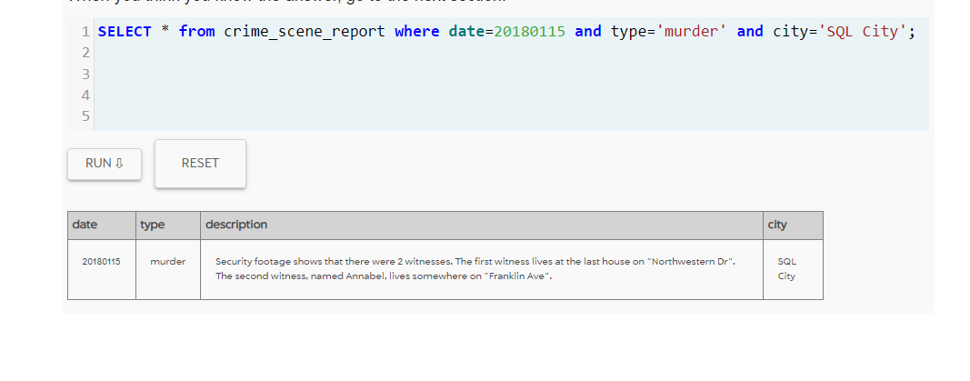
Testigos:
SELECT id,name FROM person WHERE address_street_name='Northwestern Dr'
order by address_number desc limit 1;
SELECT id,name FROM person WHERE name like 'Annabel %' and address_street_name='Franklin Ave;
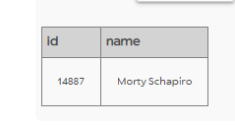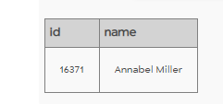

select * from interview where person_id in (14887,16371);
Va al mismo gym que anabel y es miembro de oro y numero de miembro 48Z% matricula %H42W%
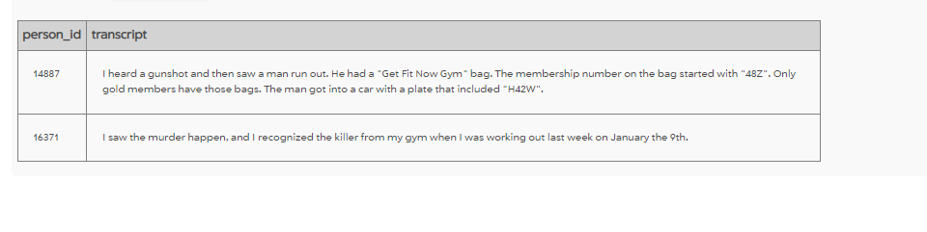
select g.id,g.name, g.person_id, d.plate_number from get_fit_now_member g, person p, drivers_license d, get_fit_now_check_in gc WHERE g.person_id=p.id and d.id=p.license_id and g.id=gc.membership_id and g.id LIKE ('48Z%') and membership_status='gold' and d.plate_number LIKE'%H42W%' and gc.check_in_date='20180109';

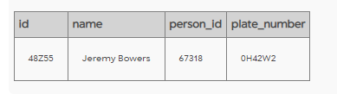
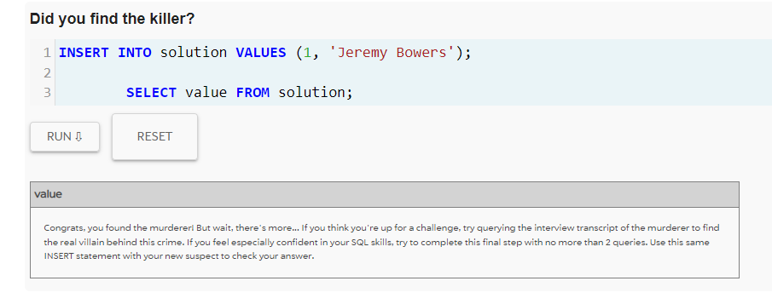
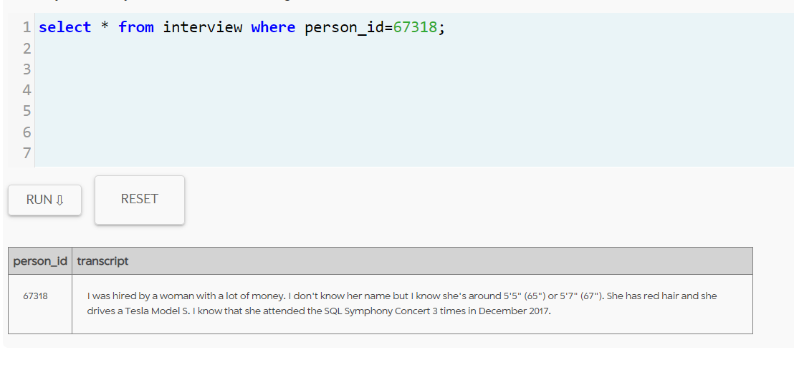
SELECT t1.person_id, p.name FROM (select person_id, count(*), event_id from facebook_event_checkin
where event_name='SQL Symphony Concert' and date BETWEEN 20171201 AND 20171231
group by person_id having count(*)=3) as t1, person p, drivers_license d
where t1.person_id=p.id and p.license_id=d.id and hair_color='red' and height BETWEEN 65 AND 67;
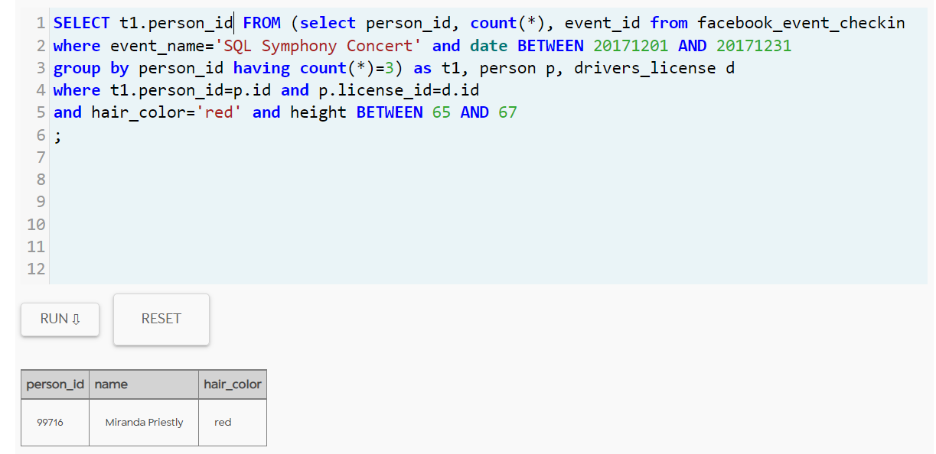
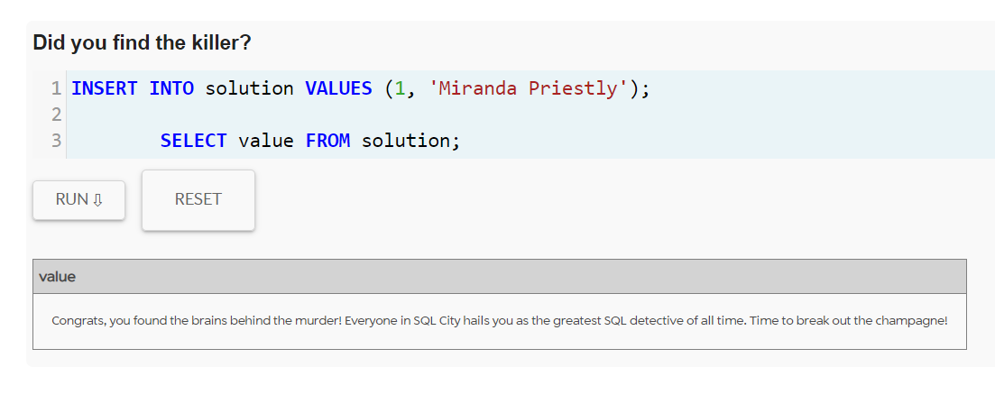

https://mystery.knightlab.com/#experienced

